Yaesu General

# Geoff Anderson G3NPA and Aki Yoshida JA1NLX

## 1.0 CAT CONNECTION TYPES

There are three types of connections for using CAT with Yaesu radios.

Note: DTR/RTS setting in Radio setup table.

You may need to check either of “Set DTR high” or “Set RTS high” option. It depends on your radio and CAT interface.

### 1.1 Type A

Radio has 8 Pin DIN Mini jack for CAT. You need CT-62 cable (or equivalent) to connect to PC’s serial port.

Example radios: FT-857, FT-897, etc.

### 1.2 Type B

Radio has RS-232C port. A standard RS-232C cable is connected between the radio’s RS-232C port and the PC’s serial port.

Example radios: FT-1000MP, FT-2000D, FTDX-1200, FTDX-5000 etc.

### 1.3 Type C

Radio has both RS-232C port and USB port. You may use either of them.

To use the radio’s RS-232C port, connect a standard RS-232C cable between the radio’s RS-232C port and the PC’s serial port.

To use the radio’s USB port, connect a USB cable between radio’s USB port and the PC’s USB port. You must install a USB driver correctly.

Example radios: FTDX-3000, FT-991 etc

**Note for Type A and Type B radios** If your PC has USB ports but no RS-232 ports, you will need a USB-to-Serial adapter in line with your RS-232 cable. Users of many different logging programs have reported difficulties when using an adapter based on anything other than a genuine FTDI chip. The latest driver for your specific operating system can be found at www.FTDIchip.com or obtained from the manufacturer of your adapter.

## 2.0 BASIC CAT COMMAND PROTOCOL

There are 2 types of protocol. One was used in older radios and another is used in newer radios.

### 2.1 Protocol used in older radios

The protocol is original. Please read operation manual carefully. Example of basic request command and reply data used in FT-897.

Request

03 ‘request fequency and mode

Reply

02 11 75 00 01 ’21.175MHz USB

Request

02 11 75 00 01 ‘Set frequency 21.175MHz

Radio Debug Window shows request command and reply data for FT-1000MP. FT-1000MP is configured as Radio 2 in this case.

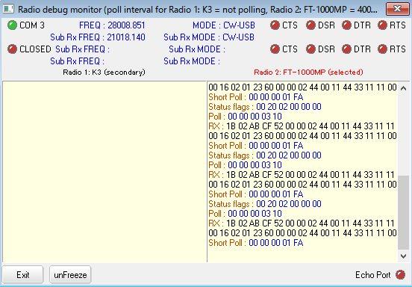

YG_1

### 2.2 Protocol used in newer radios

The protocol is similar to Elecraft and Kenwood radios. Examples of basic request command and reply data below.

Request

IF;

Reply

Ifxxx....xxx; xxx is 28 byte data followed by terminator “;”. It shows radio’s frequency, mode etc.

Request

FA;

Reply

FAxxx....xxx; xxx is 8 byte data followed by terminator “;”. It shows radio’s VFO A frequency.

Request

MD;

Reply

MDxx; x is 2 byte data.followed by terminator “;”. It shows radio’s mode parameter.

**Note**: There may be some differences in data structure for each radio.

## 3.0 MEM MODE

When Logger32 polls radio for Frequency and Mode of VFO-A, it only reports the correct frequency and Mode if the radio is in VFO mode. If the radio is in MEM, M-TUNE or QMB, an error flag will pop up on the RCP spectrum and the bottom of the radio de-bug window. This flag advises the operator to turn off the MEM. M-TUNE or QMB as appropriate.

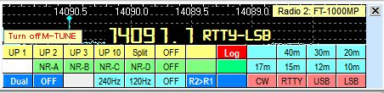

YG_2

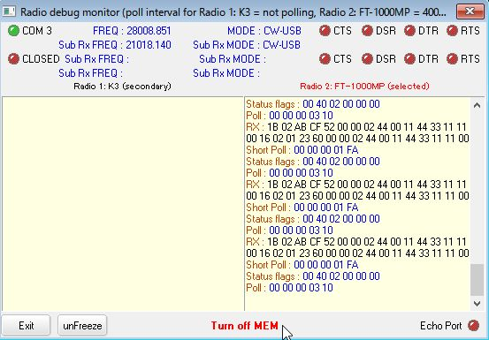

YG_3

## 4.0 FILTER SELECTION

Some Yaesu sets will store selected filter setting for each mode with in the set. If you select a mode manually or by clicking a DX spot then the radio will use its stored filter settings.

Logger32 provides an alternative way to set the filters according to mode and this is achieved by adding details into the Filter Setup window. See details in the Port Setup section of Setup Radio Control.

Add the following commands:

CW=XXXXXX

USB=YYYYY

LSB=ZZZZZZ

Where X…X,Y….Y and Z…Z represents the command to set the filter.

An imaginary entry could be:

USB=00 00 90 41 75

LSB=00 00 90 41 75

CW=00 00 00 01 0C 00 00 00 00 8C

The operator is strongly advised to consult their user manual for the radio to gain the appropriate command codes.